Unit 2 Summative Review Packet

Directions: For each document, read closely and annotate as you go by underlining important details and writing notes in the margin. Then, answer the questions that follow.
Document #1
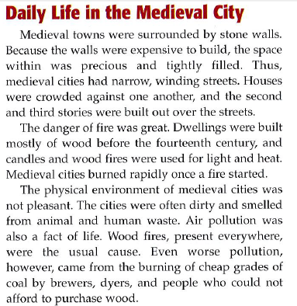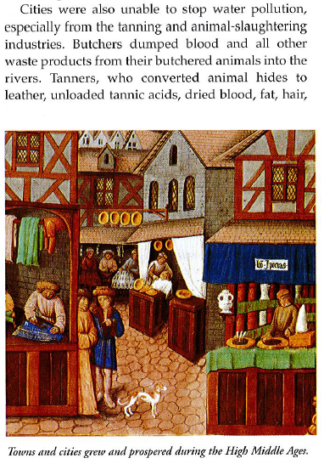

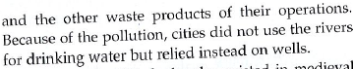

- Based on Document #1, what caused the crowding of Medieval cities?
  - It was easier to build within the stone wall surrounding the city.
  - It was cheaper to build within the stone wall surrounding the city.
  - It was important to build within the stone wall surrounding the city to prevent fires.
  - People believed that the land in Medieval cities was precious and did not want to build anywhere else.

- Based on Document #1, what is the most likely meaning of the word dwelling as it is used in paragraph 2?
  - Fire
  - Pollution
  - House
  - Castle

- According to document #1, which of the following is an EFFECT of the water pollution in Medieval cities?
  - Butchers dumped blood and animal waste into rivers.
  - The danger of fire was great.
  - The plague spread quickly.
  - People relied on wells for drinking water.

- According to Document #1, which of the following was the most significant cause of air pollution in Medieval cities?
  - Burning coal
  - Animal and human waste
  - Wood fires
  - Tannic acids
Document #2
Below is a list of fire protection laws from 13th century England.
Concerning the building of ovens No man or woman is to build an oven, furnace, or chimney next to any partition-wall, lath-work, or boards whereby the fire might easily cause a disaster.
Concerning ladders All residents of large houses are to have one or two ladders on hand, available for assisting their neighbours in the unfortunate event of an outbreak of fire.
Concerning barrels filled with water Every occupant of such houses shall have, during summertime and especially between Pentecost and the feast of St. Bartholomew [24 August], in front of his house a tub full of water for putting out any such fire, if the house does not have its own source of water.
Concerning the carpentry of houses No house is to be roofed with anything other than lead, tile or stone. If any other exists, it may be pulled down immediately by the constables¹. (¹ Police officers)
- What is the purpose of Document #2?
  - To give instructions on how to build a house
  - To explain the danger of fire
  - To try to limit the damage caused by fires
  - To increase awareness about water pollution

- Which of the following statements from Document #1 best explains the cause of Document #2?
  - “Medieval cities burned rapidly once a fire started.”
  - “Candles and wood fires were used for light and heat.”
  - “The physical environment of medieval cities was not pleasant.”
  - “Medieval towns were surrounded by stone walls.”

