Station Standard: Identify Cause and Effect SSH1.1A
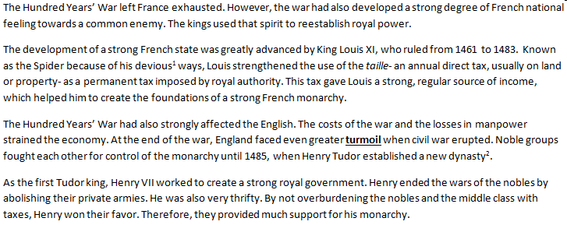

- What negative effect did the Hundred Years’ War have on England?
  - The Hundred Years’ War led to a civil war in England.
  - The Hundred Years’ war weakened England’s economy.
  - The Hundred Years’ War led to a new dynasty in England.
  - The Hundred Years’ War angered nobles in England.

- According to the document, what caused nobles to provide Henry VII support for his monarchy?
  - He abolished their private armies.
  - He limited the amount they had to pay in taxes.
  - He established a new dynasty.
  - He strained the economy.

- According to the document, how did King Louis XI to strengthen the French state?
  - By strengthening the economy
  - By eliminating turmoil
  - By creating the foundation of a strong French monarchy
  - By imposing a permanent land tax

Station Standard: Long and Short Term Effect SSH1.1B
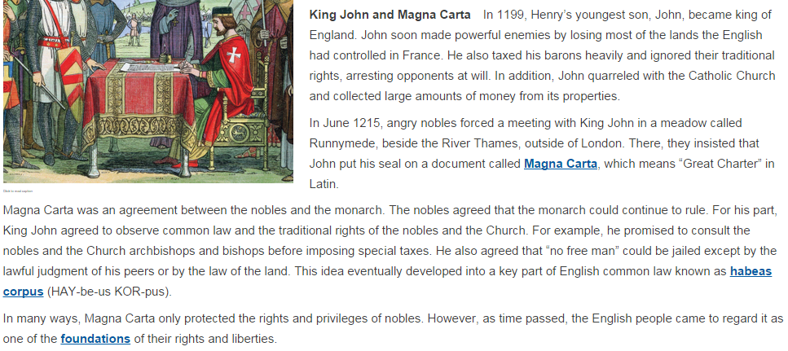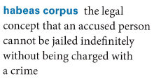
- What was the short term effect of the Magna Carta?
  - Habeas Corpus was created, giving more rights to the individual.
  - The Magna Carta created a foundation of rights and liberties for individuals in England.
  - The Magna Carta protected the rights of the nobles against the monarchs.
  - The nobles were upset with the monarch because of taxes and property loss.

- What was one of the long term effects of the Magna Carta?
  - Habeas Corpus was created, giving more rights to the individual.
  - The Magna Carta created a foundation of rights and liberties for individuals in England.
  - The Magna Carta protected the rights of the nobles against the monarchs.
  - The nobles were upset with the monarch because of taxes and property loss.

Station Standard: Read Maps SSH5.1A
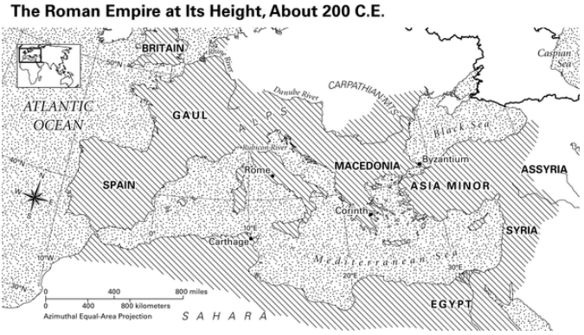
- Based on the map, which three geographic formations acted as the northern borders of the Roman Empire at its height?
  - Black Sea, The Alps, and the Danube River
  - The Alps, the Black Sea, and the Mediterranean Sea
  - The Atlantic Ocean, the Caspian Sea, and the Sahara Desert
  - Britain, Gaul and Macedonia

- What form of transportation was most likely used to transport goods between Rome and Carthage?
  - Airplane
  - Boat
  - Taxi
  - Horse

- When Constantine relocated the Roman capital from Rome to Byzantium, which direction did he travel?
  - Southeast
  - Southwest
  - Northeast
  - Northwest

Station Standard: Analyze Maps SSH5.1B

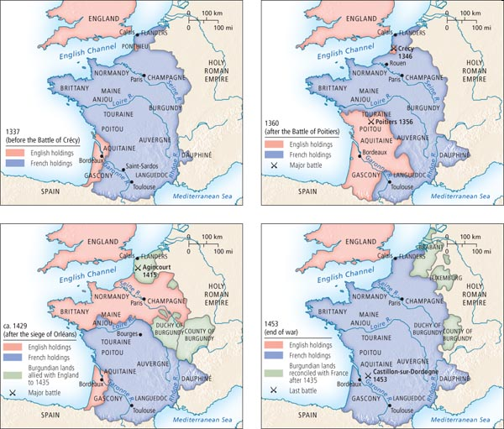

- What was the result of the Hundred Years War according to the map?
  - England gained new territory from France.
  - France regained territory from England.
  - England gained control over Burgundian lands.
  - Neither England nor France gained new territory.

- Who can you infer won the Battle of Poitiers?
  - English
  - French

- Which answer choice best captures how to explain the answer to question #2?
  - By Map 4, the location of the Battle of Poitiers is blue, which indicates the French won.
  - In Map 2, the location of the Battle of Poitiers is red but then in Map 3, it’s blue. This shows that the French won.
  - In Map 1, the location of the Battle of Poitiers is blue which means that the French originally own the land. However, Map 2 shows that by the end of the Battle of Poitiers, the English won because it is red on the map.
  - In Map 2, the Battle of Poitiers is red, so the English won.

Station Standard: Analyze through Lens of Time Period SSH2.2C
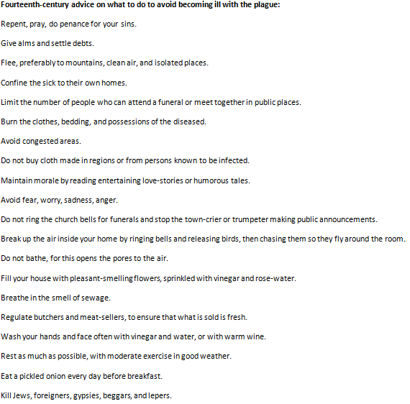

- Throughout the source, which of the following answer choices is NOT cited as a cause for the plague?
  - Committing sins
  - Jews, foreigners, and beggars
  - People with the plague, as it’s contagious
  - Sewage

- Imagine you are person living in Europe during the time of the plague. Based on the text above, how might you change your perspective of the world after experiencing the plague?
  - Your perspective on the world would change because you would no longer be religious.
  - Your perspective on the world would change because your whole family died.
  - Your perspective on the world would change because you would feel like you had no control over your fate.
  - Your perspective on the world would change because you would be afraid to meet anyone new.

- Based on the text, what can you infer was true of Medieval Europe before the plague?
  - Churches were on every block.
  - Most people did not read often.
  - Europe did not trade with outsiders.
  - People often went to funerals of their community members.

Station Standard: Identify Main Idea RH.6-8.2
Background: Monks were men who joined monasteries, communities devoted to prayer and service to fellow Christians. Benedictine monks, who followed the teachings of Saint Benedict, made three solemn vows: poverty (to own no property), chastity (never to marry), and obedience (to obey their leaders).

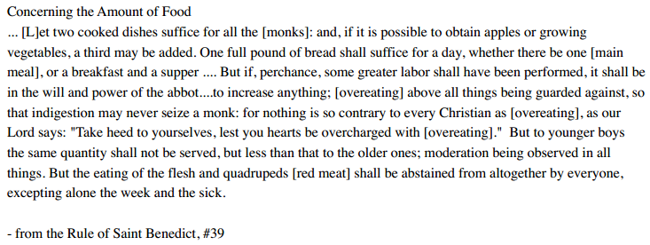

- Based on rule #39, which answer choice best describes the basic food allowance a Benedictine monk may receive per day?
  - 2 cooked dishes to all monks and bread
  - No limit, these monks could eat as much as the Lord wanted
  - 1 full pound of bread
  - 3 meals per day at minimum

- How might a monk receive more than the normal amount of food?
  - By Asking nicely
  - By overeating
  - By eating meat
  - By production of more fruits/ vegetables

- What is the most likely reason that Benedict is concerned with overeating and the amount of food younger boys may eat?
  - For monks to practice moderation and discipline
  - To avoid obesity
  - To have a long and healthy life
  - To show appreciation to the Lord for what they do have

Station Standard: Cite Evidence RH.6-8.1

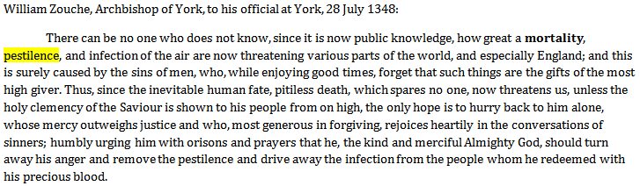

- What does the quote, “and this is surely caused by the sins of men, who, while enjoying good times, forget that such things are the gifts of the most high giver,” mean?
  - The plague is caused by men who commit sins and who are not thankful to the Lord.
  - The plague is caused by men being careless.
  - The plague is caused by men who are just enjoying themselves, not being careful.
  - The plague is caused by men who are selfish with their gifts from the Lord.

- Which piece of evidence best captures the purpose of this primary source?
  - “…and the only hope is to hurry back to him alone,”
  - “…humbly urging him with orisons and prayers that be…”
  - “…should turn away his anger…”
  - “ There can be no one who does now know…how great a mortality, pestilence..”

- Which piece of evidence best shows the author’s point of view on the cause of the plague?
  - “…and this is surely caused by the sins of men.”
  - “ while enjoying good times, forget that such things are the gifts of the most high giver.”
  - “ … rejoices heartily in the conversations of sinners..”
  - “…and infection of the air…”

Optional Challenge Work:

Using the source below, create multiple choice questions based on the following standards:
H2.2C Analyze through Lens of Time Period
H1.1A Cause and Effect
RH.6-8.1 Cite Evidence
RH.6-8.2 Main Idea

Knights in Medieval England lived by a strict code, called the Code of Chivalry:

