Instructions: Read the following text and answer the comprehension questions bellow. Annotate the text for reasons why you think the Roman Empire collapsed. 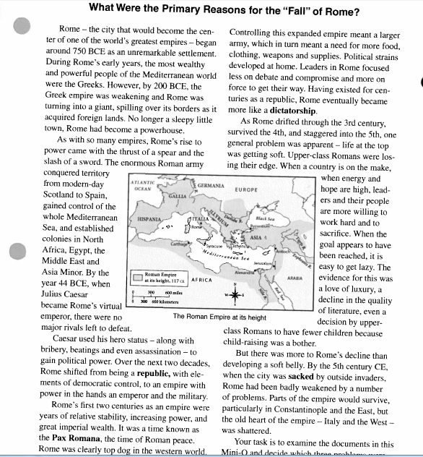

Question | Your Answer | Best Evidence to Support Your Claim (write out the quote)
How many years passed between Rome’s early days as a sleepy little settlement and its invasion in the 5th century CE?
What was the Pax Romana?
In what way did the form of the Roman government change around the time of Julius Caesar?
Beginnning inn the 3rd century, Rome was developing a “soft belly.” What does that mean?

