MLA:

“Fall” of Rome DBQ Packet
Keep this in your binder at all times and do not lose it!!
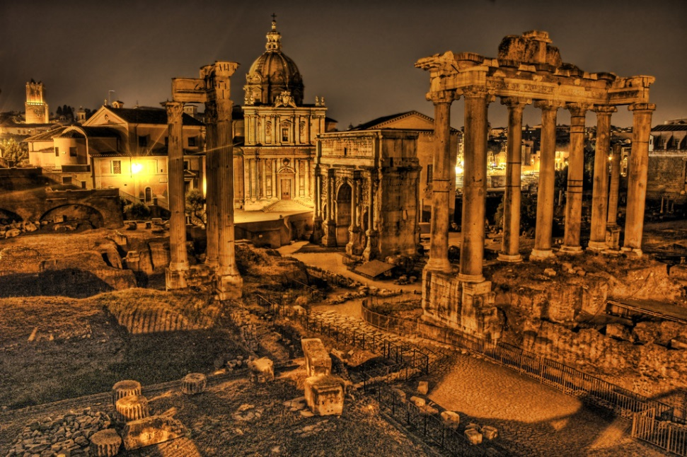

Essential Question:
What was the primary cause for the Fall of Rome?

DOCUMENT A
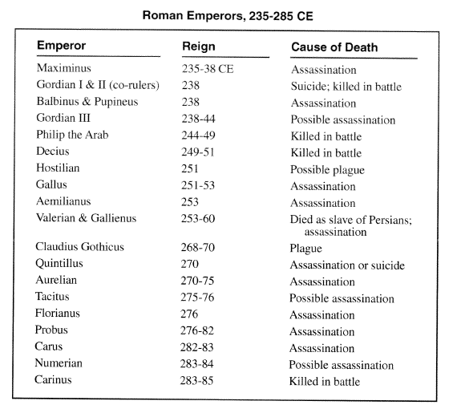

Assassination: | The act of murdering an important person for political or religious reasons
Reason for the Fall of Rome:
Category:

DOCUMENT B
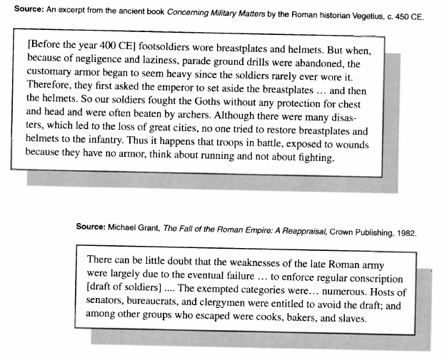

Negligence: | Failure to take proper care of someone or something
Infantry: | Soldiers marching or fighting on foot
Exempted: | Free or excused from an obligation
Reason for the Fall of Rome:
Category:

DOCUMENT C
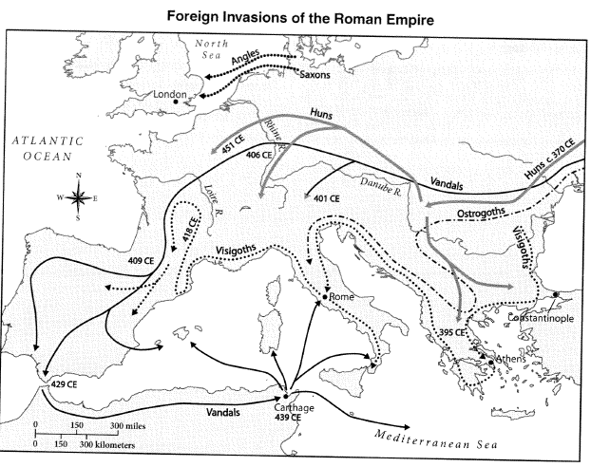

Reason for the Fall of Rome:
Category:

DOCUMENT D
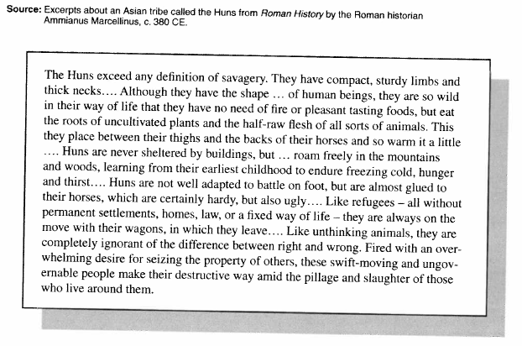

Savagery: | The quality of being fierce or cruel
Pillage: | Rob using violence (especially during wartime)
Reason for the Fall of Rome:
Category:

DOCUMENT E
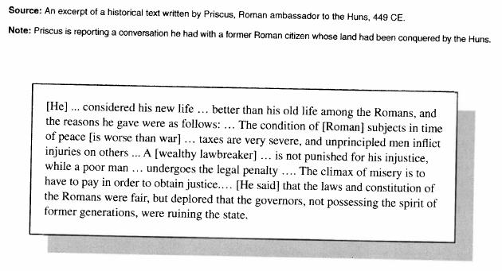

Injustice: | Lack of justice or fairness
Reason for the Fall of Rome:
Category:

