MLA:

10.23 Homework
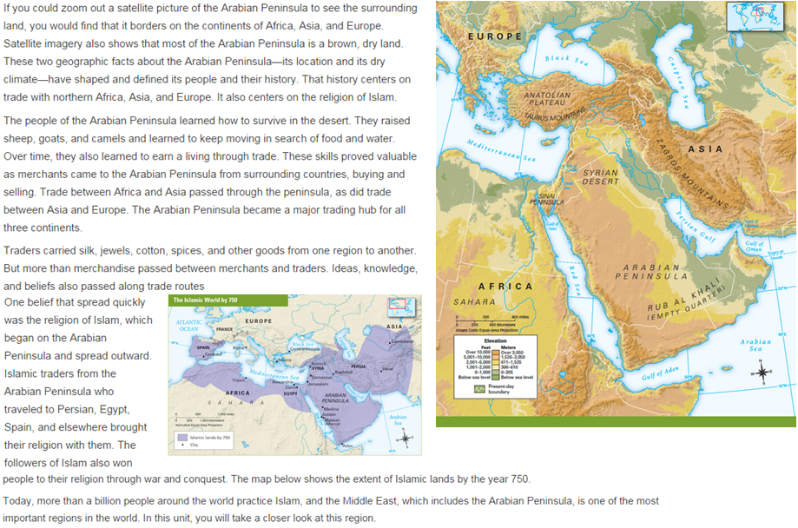

MLA:
10.23 Homework

Which two geographic features shaped the history or culture of the Arabian Peninsulas? Identify the geographic features and explain.

 | ACE Master (2) | Getting there (1) | Below expectations (0)
A | Answer is correct and restates/answers the question effectively | Answer is too simple | Does not answer question
 |  | Answer is not in a complete sentence | Answer is unclear or inaccurate
 |  | Answer is slightly off
C | Evidence effectively supports the answer  Does not include extraneous evidence | Evidence somewhat supports the answer | Evidence is absent or does not support the answer
 |  | Some of the evidence supports the answer
 |  | Some extraneous evidence is included
 |  | Not enough evidence is included
E | Effectively explains the meaning of the evidence and how it proves the answer | Explanation only connects to answer | No explanation present
 |  | Explanation only connects to evidence | Explanation is vague
 |  | Explanation simply repeats evidence and/or explanation | Explanation is inaccurate
 |  | Explanation is slightly off

